Peel School Bicycle Parking Program
Information for Schools and Application Form
The goal of the Region of Peel’s School Bicycle Parking Program is to encourage Peel students to cycle to and from school by providing safe and secure bicycle parking. It is one of a variety of initiatives that promote cycling and walking to school as part of Peel’s School Travel Planning program. In the pilot phase of the project in 2014-2015, 41 schools were given new bike racks. Based on the success of the pilot project in increasing cycling and participation in active school travel programming, as well as increasing demand for cycling infrastructure, the School Bicycle Parking Program will be offered on a regular basis starting in the 2016-2017 school year.
Due to limited funding, applications will be prioritized based on a set of criteria, including demonstrated need, participation in sustainable transportation programming, and technical specifications (detailed on the next page). A maximum of 3 “Inverted U Series” bike racks, each with a capacity for securing 8 bicycles, will be provided to selected schools by the Region of Peel.
Interested schools are encouraged to participate in the School Bicycle Parking Program. Applications are due by November 4, 2016.

For additional information, and to send in your completed application, please contact walkandroll@peelregion.ca or 905-791-7800 ext. 8389.

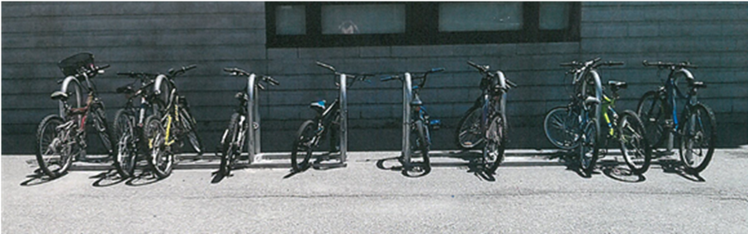
Peel School Bicycle Parking Program
Application Procedure and Conditions
- Schools must email the completed application form to walkandroll@peelregion.ca no later than November 4, 2016.
- Funding is only available for a limited number of bike racks, so not all schools who apply for the School Bicycle Parking Program in 2016-2017 will receive a bike rack. Schools who request more than one bike rack may be approved for less than the number of bike racks they request.
- Selection Criteria - Applications will be reviewed and selected based on the following:
- Demonstrated need for safe and secure bicycle parking;
- Current involvement in Peel School Travel Planning;
- Involvement and commitment to sustainable transportation education and outreach programs, i.e. Bike to School Week, EcoSchools, previous bicycle parking initiatives, or other presentations, training, or programs;
- Total school student population;
- Existing and planned bicycle infrastructure on school grounds and in the surrounding area; and
- Bicycle parking area and appropriateness of the proposed location of the facilities, in accordance with the Region of Peel’s technical requirements and/or site analysis involving the School Boards, the School, and Peel staff.
- Technical Requirements - All proposed locations should meet the following technical requirements to optimize the usage of the bike racks:
  - Near main entrance or other high-traffic entrance to the school;
  - Visible from streets, paths, or other right of ways;
  - Minimum site dimensions for each bicycle rack: 4.0m x 1.8m;
  - Minimum buffer from walls, walkways, or other right of ways: 0.6m;
  - Recommended criteria: concrete surface, weather protected, under surveillance.
- Selected schools and school boards will be notified via email. The bicycle rack (s) will be installed at approved on-site locations as per each application, and according to the manufacturer’s specifications.
- The Region of Peel and school boards will make every effort to install bicycle racks in a timely manner, but schools should be aware that it may be several months between the time their application is approved and the requested bike racks are installed. We anticipate that bicycle racks will be installed in spring 2017.
- The Region of Peel will pay for the entire cost of each bike rack for successful applicants. The Region will also pay for the cost of installation of the bike racks, to a maximum of $400 per rack. In most locations, this should cover the entire cost of installation. However, any additional installation costs will be the responsibility of the relevant school/school board.
- Photographs showing installed bike racks in their location must be provided to the Region of Peel within 60 days of installation.
- Bicycle parking facilities must not be moved or removed except for on-site maintenance purposes (e.g. snow clearance) or with written permission of the Region of Peel.
- The school and/or school board will be responsible for keeping the bicycle parking facilities clear of snow and leaves.
- Successful schools, with support from the Region of Peel, will be expected to collect baseline and final data on transportation modal choices and usage of the bicycle racks.
- The Region of Peel accepts no liability for the construction, operation, destruction or theft of the bicycle racks.
PEEL School Bicycle Parking Program
2016-2017 Application form

School name: | Address:
Type of school:  □ Elementary □ Middle □ Secondary | Main contact person:
Telephone number: | Email:
School Board:  □ Peel District School Board (PDSB)  □ Dufferin-Peel Catholic District School Board (DPCDSB) | Involvement in sustainable transportation initiatives (check all that apply):  □ Healthy Schools Committee  □ School Travel Planning (STP)  □ Bike to School Week  □ EcoSchools  □ Other (please specify):  _______________________________________
Quantity of bike racks requested  (each rack accommodates 8 bicycles)  □ 1 □ 2 □ 3 | Total # of students: ______  Approx. # of cyclists: ______
Where are bicycles currently parked on-site? (Check all that apply)
□ Bicycle rack(s)* *How many bicycles can be accommodated at current bike racks? ____
□ Fences/trees/posts □ Indoors □ Other (please specify): ______________________________
Please provide an on-site photo showing any current bicycle parking facilities.
Describe the proposed location of the rack(s):
Please include the type of surface at the proposed location (e.g. concrete, asphalt).
For example: “north side of the building facing the parking lot, on concrete surface XX metres west of the entrance, XX metres from the building, XX metres from the curb”. Attach a map or sketch if needed.
Note that minimum site dimensions for each rack are 4.0m X 1.8m

Commitment to the Region of Peel (check the boxes below)
□ Our school will work with the Region of Peel to promote walking and cycling to school
□ Our school will assist the Region of Peel by collecting data pertaining to the usage of the bike racks
Name: | Date:
Signature:

Please feel free to provide additional photographs or other information that demonstrates your school’s need for bicycle parking facilities, or past commitment to bicycle or sustainable transportation programming.

Application Deadline: November 4, 2016
Please email completed applications to walkandroll@peelregion.ca

